# Astronomy 205: Problem set 1

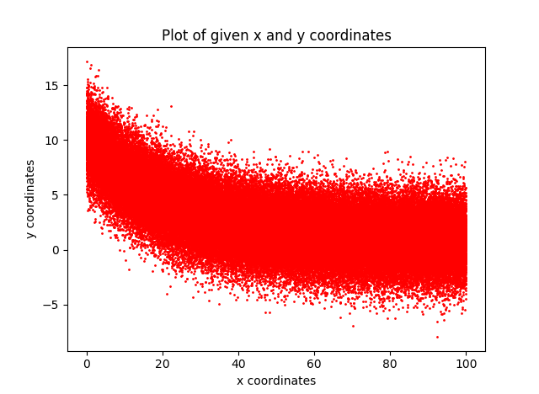1a)

1b)

Using the Scipy.Optimize in built function. I was able to fit an exponential curve following the given equation given in the question. The noise was unable to decided

**The fitted parameters:**

A = 9.402 +/- 0.01365

B = -21.69 +/- 0.07178

C = 0.796 +/- 0.006729

While at it, the goodness of fit can also be determined in order to see how well the curve describes the data given

**Goodness of fit, via Chi squared**

Chi squared per degree of freedom = 1.011

This shows that the fit is a good fit of the data given

1c)

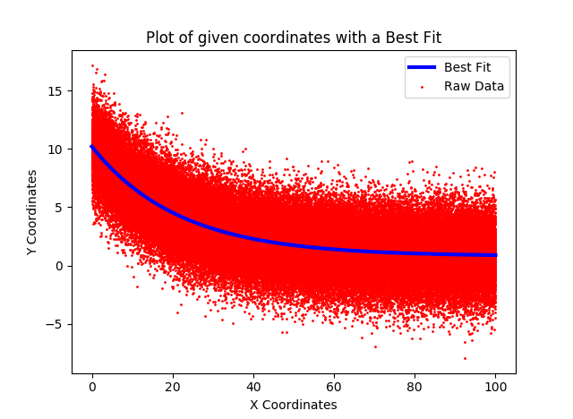

The curve loos very reasonable as it follows the general trend of the data as x increases.

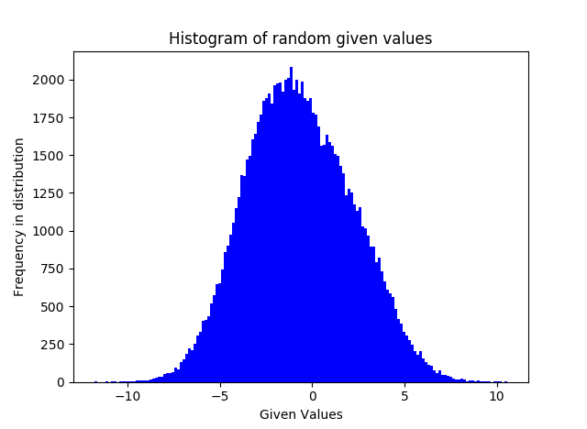2a)

Although the points look like normalized curve (and in turn, Gaussian) around x value of -1 but due to the deviations around the around the tip and the x-value of 1 show that it is not perfect

2b) Using the inbuilt Shapiro-wilk Normalized test with python, the p-value of the histogram can be determined and in turn, seen if it follows the a gaussian distribution. As it compares the p-value with the alpha of the histogram (which is given 0.05).

Normality test p-value (Shapiro-Wilk) = 9.014e-39

Given alpha (for comparison): 0.05

Data is not Gaussian as it has failed the Normality test

2d) using the optimize import from Python’s Scipi inbuilt function, the two Gaussian curves will optimize itself to the histogram and in turn generate values for C1, C2, Sigma1, Sigma2, Mean1, Mean2.

C1 = 4.463e+03

C2 = 1.046e+04

Sigma1 = 2.033

Sigma2 = 2.238

Mean1 = 2.188

Mean2 = -1.886

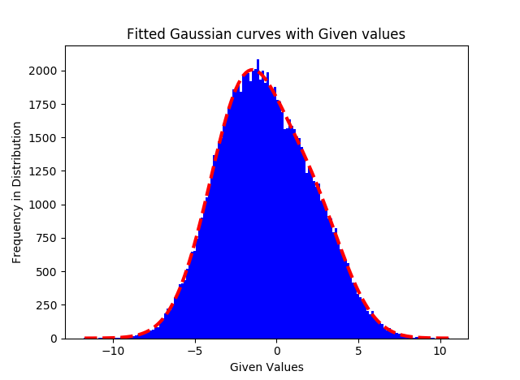2e)

For the most part, it covers most of the histogram in such a way that makes it Gaussian, but as it can be seen around the peak and continuing, it begins to deform and starts to not encompass all the raw data. So although, the Gaussian curve normalizes itself over the histogram, the curvature could be better to encompass the points.